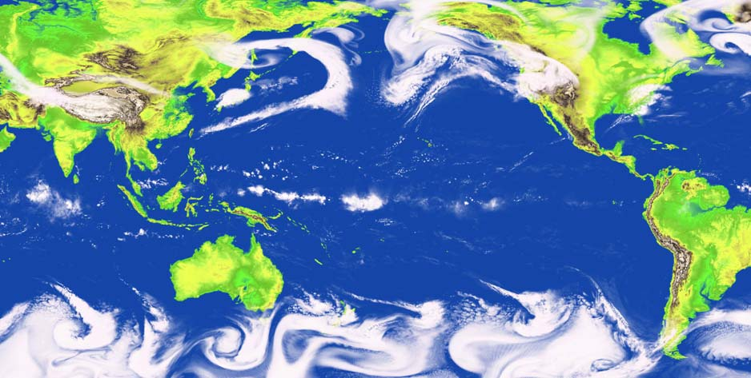
Pacific Storms Climatology Products
Coastal storms, and the strong winds, heavy rains, and high seas that accompany them, pose a threat to the lives and livelihoods of the peoples of the Pacific.
To reduce their vulnerability to the social, economic, and environmental risks associated with these phenomena communities and businesses, as well as government agencies and the scientific community, need access to information that enables them to better understand, anticipate, and adapt.
Image courtesy of NOAA’s Geophysical Fluid Dynamics Laboratory
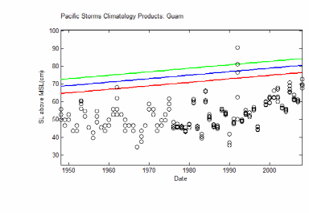
This site provides access to an integrated suite of products that delineate patterns and trends of storm frequency and intensity - "storminess"- within the Pacific region. These products will help users to explore how extreme events have been expressed historically and may be expected to be expressed in a changing climate.
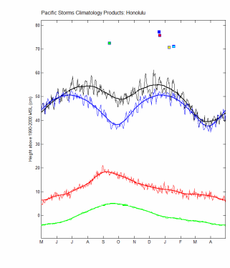
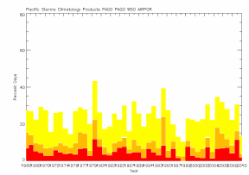
These products are derived from analyses of historical records collected from in-situ stations located throughout the Pacific. They include the delineation of rates of sea level rise and high water return periods, as well as changes in the frequency of both short-lived intense rainfall events and extended periods of heavy rains and the linkages of these patterns and trends to climate indices. Such information is critical to scenario development in support of climate change and natural hazards vulnerability assessment. As such, it is directly applicable to coastal land-use planning and resource management. It also forms the basis for establishing infrastructure (e.g., roads, water, sewer) design criteria.

The primary audience for these products is scientists, engineers, and others with a technical background.
BOX- Go to the query tool to view inter-annual and annual extremes climatology-related data products by region process, indicator, and product type.
This site also provides access to information that will help non-technical users to learn about the climate-related processes that govern extreme storm events.
BOX- Go to the regional overviews to get a summary of the extremes climatology for various regions within the Pacific, including a description of characteristic event types for a region.
See examples of how the extremes climatology products can be used.

